Data Cleaning, Wrangling & Exploratory Data Analysis

A Python-Based Analysis of the Hotel Booking Demand Dataset
Prepared by: Abhishek Pal
Computer Science Engineering (Data Science), ABES Engineering College
September 2026

1. Introduction
The hospitality industry generates large volumes of transactional data through booking systems, covering guest demographics, reservation timing, pricing, and cancellations. Analyzing this data well directly affects revenue management, staffing, and occupancy planning. This report demonstrates a complete data analysis workflow — acquisition, cleaning, exploratory data analysis (EDA), and visualization — applied to a real-world hotel booking dataset, using Python.
The objective is to identify data quality issues typical of hospitality datasets, resolve them systematically, and extract insights on cancellation behavior, pricing, and booking patterns that could inform hotel management decisions.

2. Data Acquisition
The dataset used is the Hotel Booking Demand dataset, originally published by Antonio, Almeida and Nunes (2019) in Data in Brief, and distributed in cleaned form via the TidyTuesday project. It contains real, anonymized booking records from one resort hotel and one city hotel in Portugal, covering arrivals between July 2015 and August 2017.
Property | Value
Source | Antonio, Almeida & Nunes (2019), Data in Brief; via TidyTuesday
Raw records | 119,390
Raw columns | 32
Time span | July 2015 - August 2017
Granularity | One row per hotel booking
Hotels covered | City Hotel, Resort Hotel

Key variables include hotel type, cancellation status, lead time, arrival date, stay length, guest counts, meal plan, market segment, deposit type, and average daily rate (ADR).

3. Data Cleaning and Preprocessing
Before analysis, the raw dataset was inspected for missing values, duplicate rows, invalid records, and outliers using pandas. The following issues were identified and addressed:
Issue | Finding | Action Taken
Missing values | children: 4, country: 488, agent: 16,340, company: 112,593 missing | children filled with 0; country filled 'Unknown'; company column dropped (>94% missing); agent filled with 0
Duplicate rows | 31,987 exact duplicate bookings | Removed with drop_duplicates()
Invalid records | 180 bookings with 0 adults, 0 children, 0 babies | Removed - not valid reservations
Outliers (ADR) | 1 negative ADR value; 1 extreme value (>5000) | Removed via range filter (0 <= adr < 1000)
Inconsistent types | Arrival date split across 3 columns; status date stored as text | Combined into a single arrival_date datetime column; reservation_status_date parsed as datetime

After cleaning, the dataset was reduced from 119,390 to 87,221 records. This reduction is expected and appropriate: over a quarter of the raw rows were exact duplicates, which if left in place would have distorted every summary statistic and chart by over-weighting repeated bookings.
Two derived features were engineered to support analysis: total_nights (weekend + week nights) and total_guests (adults + children + babies).

4. Exploratory Data Analysis

4.1 Summary Statistics
Metric | City Hotel | Resort Hotel
Bookings | 53,271 | 33,950
Cancellation rate | 30.10% | 23.49%
Average ADR | 111.17 | 99.07

Overall cancellation rate across both hotels is 27.53%. City Hotel bookings are cancelled more often and priced higher on average than Resort Hotel bookings.

4.2 Distribution of Lead Time and ADR
Lead time (days between booking and arrival) is right-skewed - most guests book within a few months, but a long tail books far in advance. Average lead time is 80 days overall, but 105.7 days for cancelled bookings versus 70.2 days for completed stays - early bookers are more likely to cancel.
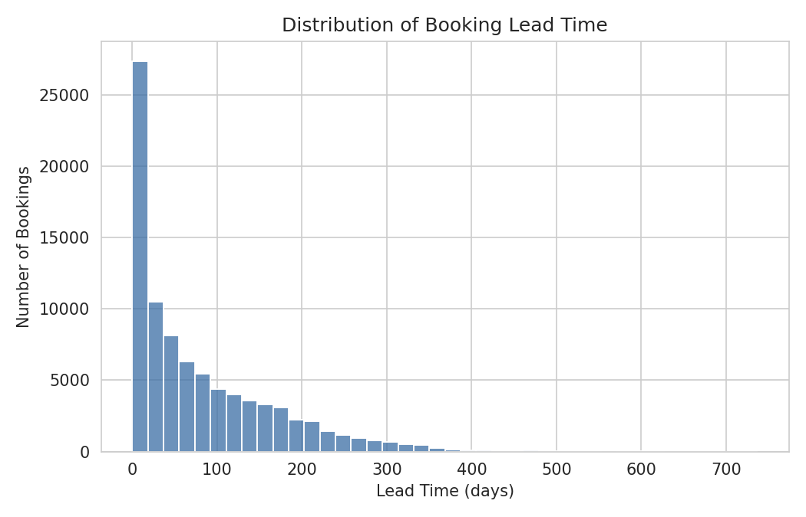
Figure 1. Distribution of booking lead time.
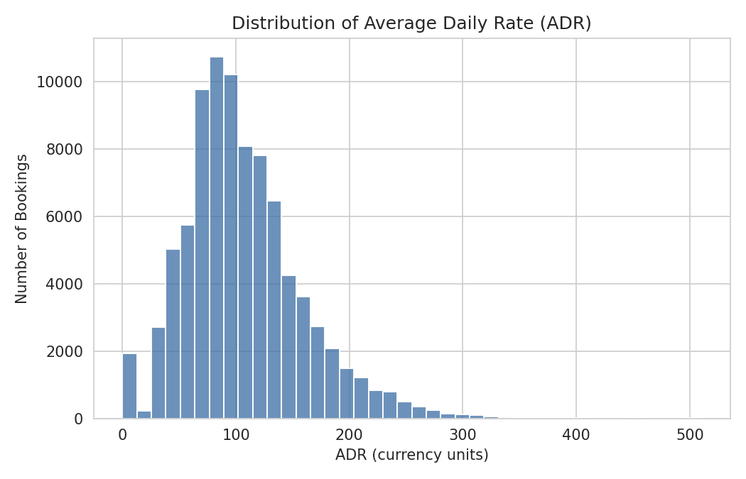
Figure 2. Distribution of Average Daily Rate (ADR).

4.3 Outlier Check: ADR by Hotel Type
A box plot confirms City Hotel has both a higher median ADR and a wider spread of pricing than Resort Hotel, consistent with more dynamic, demand-based pricing in an urban market.
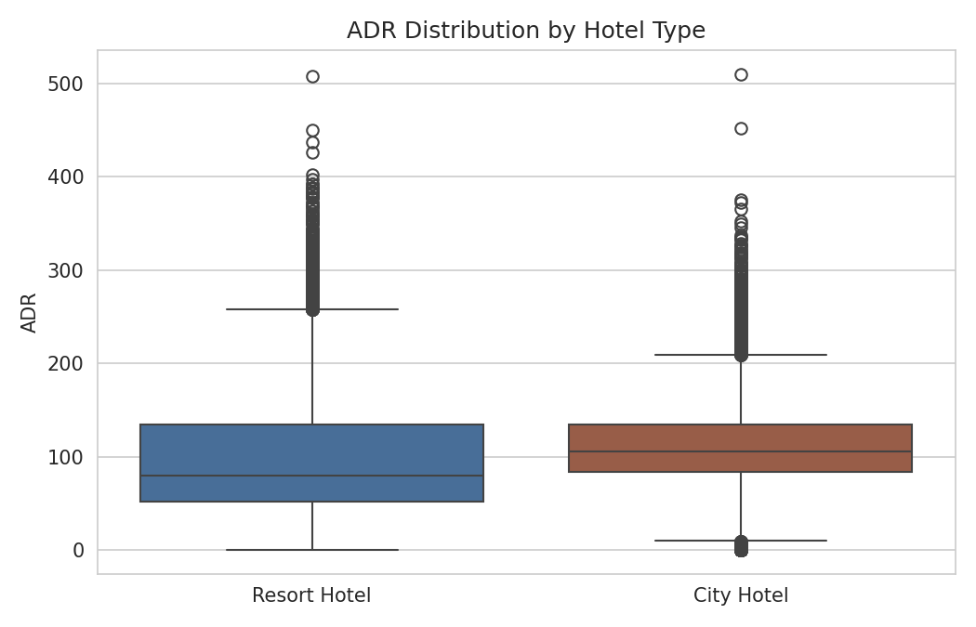
Figure 3. ADR distribution by hotel type, after outlier removal.

4.4 Cancellation Patterns
Cancellation rate varies substantially by month and by booking channel, pointing to seasonal and channel-based risk factors hotels can act on.
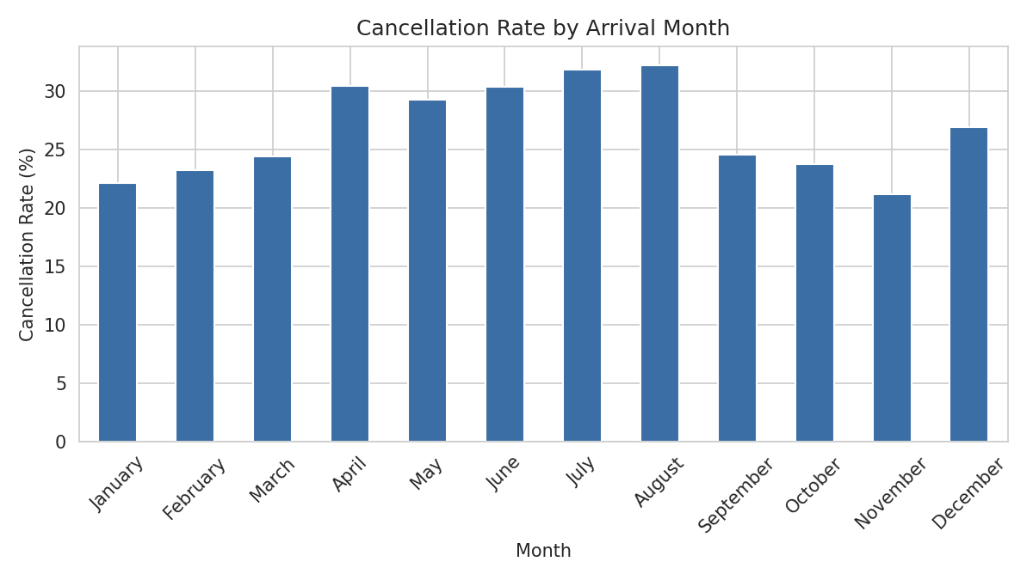
Figure 4. Cancellation rate by arrival month.
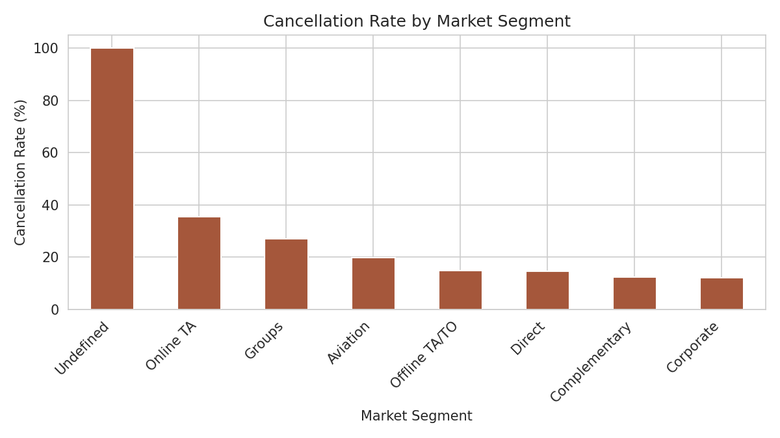
Figure 5. Cancellation rate by market segment.
Deposit Type | Cancellation Rate
No Deposit | 26.72%
Refundable | 24.30%
Non Refund | 94.70%

The Non Refund deposit segment shows a striking 94.7% cancellation rate - far higher than No Deposit or Refundable bookings. This counter-intuitive pattern (non-refundable bookings cancelling more, not less) is documented in the source literature and is associated with a specific booking-agent channel rather than genuine guest behavior, illustrating why raw correlations need contextual interpretation rather than face-value action.

4.5 Correlation Analysis
A correlation matrix of key numeric features against cancellation status shows lead_time (+0.185) and adr (+0.133) as the strongest positive correlates of cancellation, while total_of_special_requests (-0.121) and booking_changes (-0.093) are the strongest negative correlates - guests who personalize or modify their booking are less likely to cancel.
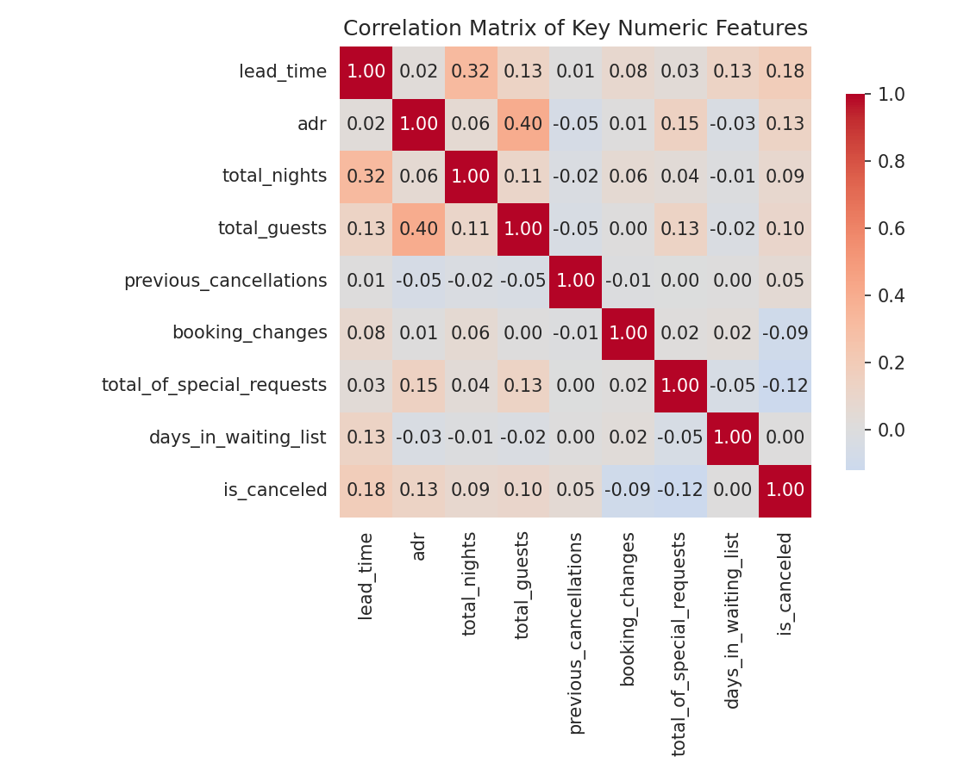
Figure 6. Correlation matrix of numeric booking features.

4.6 Lead Time vs. ADR by Cancellation Status
A scatter plot of lead time against ADR (4,000-record sample), colored by cancellation status, visualizes how cancelled bookings (orange) skew toward longer lead times without a clearly separate pricing band, suggesting lead time is a stronger individual risk signal than price.
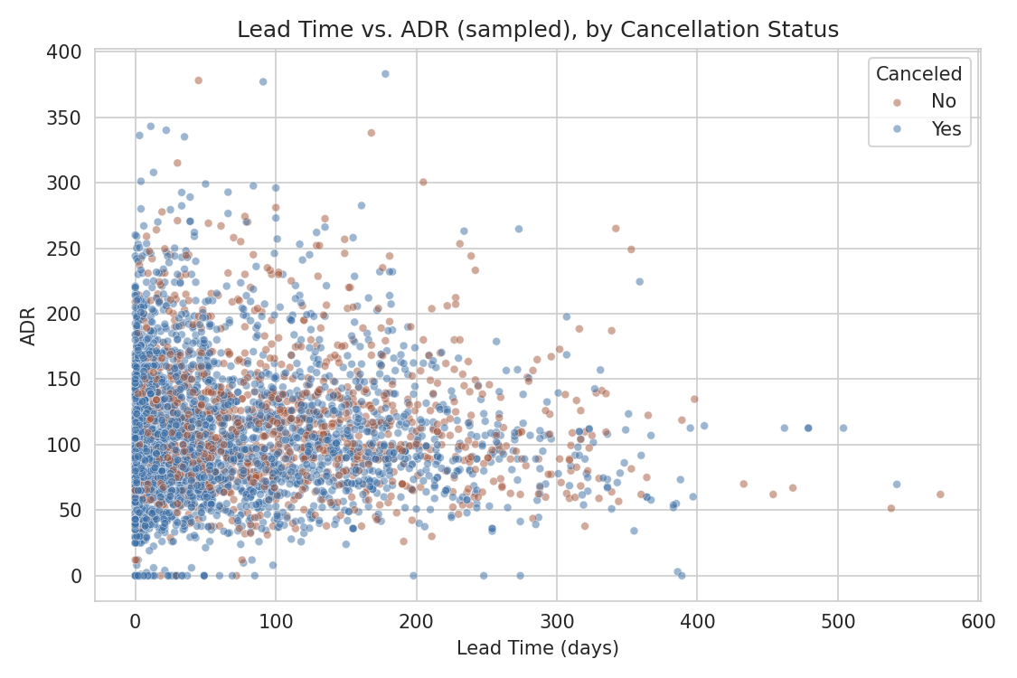
Figure 7. Lead time vs. ADR, coloured by cancellation status (sampled).

5. Key Insights
- City Hotel has a higher cancellation rate (30.1%) and higher average price (111.17) than Resort Hotel (23.49%, 99.07) - urban bookings carry more revenue risk per reservation.
- Long lead-time bookings are meaningfully more likely to cancel (105.7 vs 70.2 days average lead time for cancelled vs completed stays) - early bookings need different overbooking/deposit policies than last-minute ones.
- Online Travel Agency (Online TA) bookings cancel at 35.4%, the highest of any legitimate segment, versus 12-15% for Direct, Corporate and Offline TA/TO channels - channel choice is a meaningful risk indicator.
- Guests who make more special requests or booking changes cancel less often, suggesting engagement with a booking is a weak but real predictor of follow-through.
- Deposit type alone is not a reliable predictor of guest reliability in this dataset - the Non Refund segment's high cancellation rate reflects a specific booking channel's behavior, not deposits discouraging cancellation.

6. Recommendations for Hospitality Decision-Making
Data quality directly shapes the reliability of any decision built on it. This analysis illustrates several ways in which cleaning and EDA choices should inform hospitality operations:
- Deduplicate booking records before computing any occupancy or revenue metric - in this dataset, over a quarter of raw rows were exact duplicates, which would have inflated demand estimates by a similar margin if left uncorrected.
- Segment cancellation forecasting by market segment and lead-time bucket rather than using a single hotel-wide cancellation rate, since risk varies from roughly 12% (Corporate) to over 35% (Online TA).
- Investigate anomalous subgroups (such as the Non Refund deposit segment here) before using them in policy decisions - a high-level statistic can mask a channel-specific artifact rather than reflect real guest behavior.
- Standardize date and category fields at the point of data entry (e.g., a single arrival_date field rather than split year/month/day columns) to reduce downstream cleaning effort and the risk of parsing errors.
- Treat missing values contextually - here, a missing 'company' field usually just means a private guest, not a data error, while missing 'children' most plausibly means zero children, not a null to discard.

7. Conclusion
This analysis applied a structured data cleaning and EDA workflow to 119,390 real hotel booking records, resolving missing values, duplicates, invalid entries and outliers to arrive at a reliable analytical base of 87,221 bookings. The resulting exploratory analysis surfaced concrete, actionable patterns in cancellation behavior, pricing, and booking channels. The exercise underscores a broader principle for hospitality analytics: the value of any downstream model or dashboard is bounded by the rigor applied during data cleaning, and seemingly minor decisions - how to treat a missing value, whether to drop a duplicate, how to define an outlier - materially change the conclusions drawn.

References
Antonio, N., de Almeida, A., & Nunes, L. (2019). Hotel booking demand datasets. Data in Brief, 22, 41-49.
Mock, T., & Bichat, A. (2020). TidyTuesday: Hotel Bookings [Data set]. R for Data Science TidyTuesday project.

